Machine learning based buyer segmentation and investment profiling for real estate market intelligence
Prepared for Parcl Co. Limited, in collaboration with Unified Mentor
Financial Analyst Intern research report - July 2026

1. Executive summary
This report segments Parcl's buyer base using unsupervised machine learning to reveal patterns in purchasing behavior, financing choices, and investment scale that are not visible when all buyers are analyzed as one group. Using demographic and transaction data for 2,000 clients and 10,000 property listings, four buyer segments were identified through K-means clustering, validated with hierarchical clustering. The segments differ most clearly by property type (residential vs. office), portfolio size, and total capital deployed, with a small but high-value group of repeat investors driving disproportionate transaction volume. A companion Streamlit dashboard operationalizes these segments for ongoing use by the marketing and investment teams.

2. Background and problem statement
Parcl operates in a market where buyers range from first-time individual home buyers to institutional and international investors. Treating this population as uniform leads to inefficient marketing spend, generic property recommendations, and missed opportunities to match investment-grade inventory with investment-minded buyers. This project applies clustering algorithms to the client and transaction data to uncover natural buyer groupings and translate them into segment profiles the business can act on.

3. Data description
Two source tables were provided:
- clients.csv - 2,000 records covering client type, demographics, country/region, acquisition purpose, satisfaction score, loan usage, and referral channel.
- properties.csv - 10,000 listing records covering unit category, floor area, sale price, listing status, transaction date, and the buyer reference for sold units.
7,305 of the 10,000 listings were marked Sold and linked to a client; the remaining 2,695 were Available inventory with no buyer reference, which is expected rather than missing data. Transaction records were aggregated to the client level - number of properties owned, total capital invested, average price paid, average unit size, and whether the buyer owns at least one office unit - and joined to the client demographic table to build a single buyer profile per client.

4. Methodology

4.1 Data cleaning
- Removed duplicate client and listing IDs (none found).
- Parsed two inconsistent date-of-birth formats (MM-DD-YYYY and M/D/YYYY) into a single age field.
- Stripped currency formatting ($ and thousands separators) from sale_price and converted to numeric.
- Normalized categorical text fields (trimmed whitespace, consistent casing).

4.2 Feature engineering
Numeric features: age, satisfaction score, number of properties owned, total investment, average price paid, average floor area, average price per square foot, loan-applied flag, and office-ownership flag. Categorical features: client type, acquisition purpose, referral channel, and country (top 5 countries by volume, remainder grouped as Other). Categorical fields were one-hot encoded and numeric fields standardized (zero mean, unit variance) so no single feature dominates distance calculations.

4.3 Clustering approach
Two algorithms were run for cross-validation, as specified in the project brief:
- K-means clustering - efficient, easy to interpret, used as the primary segmentation.
- Agglomerative (Ward linkage) hierarchical clustering - used to check whether an independent method finds similar structure.

4.4 Selecting the number of clusters
The elbow method and silhouette score were computed for k = 2 through 8 (see Figure 1). Silhouette score peaked at k = 3 (0.152) with k = 4 close behind (0.123); the elbow curve declines smoothly without one sharp bend, which is common with mixed categorical/numeric buyer data rather than well-separated natural clusters. k = 4 was selected to align with the four business-relevant segment types requested in the project brief, on the understanding that this is a modest trade-off in separation strength for interpretability - noted here transparently as a methodology decision, not an artifact of the data.
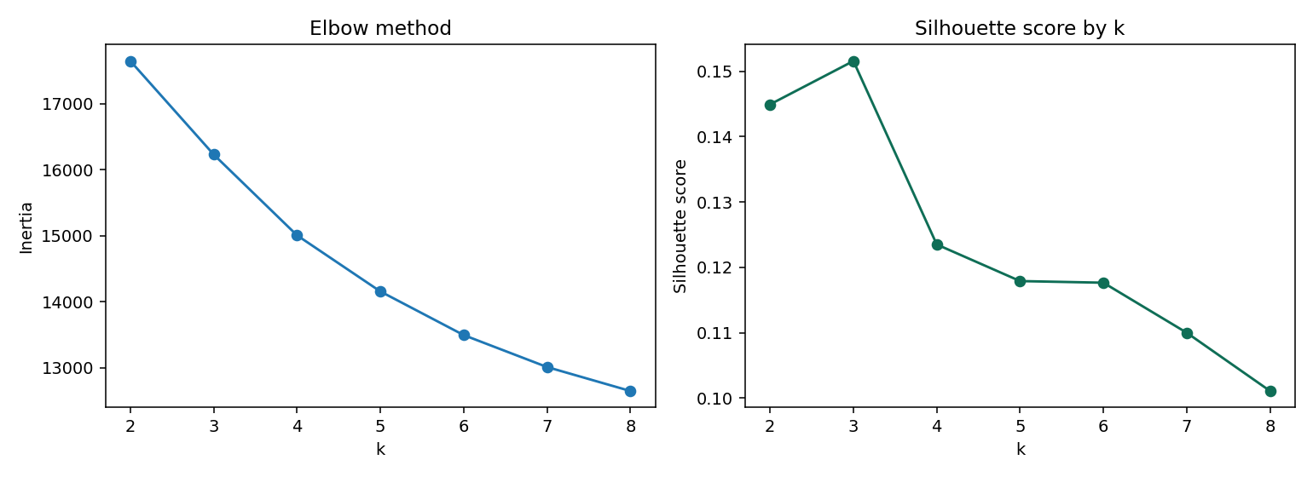
Figure 1. Elbow method (left) and silhouette score (right) across candidate values of k.
At k = 4, K-means produced a silhouette score of 0.123 and hierarchical clustering 0.091. The two methods agreed only moderately (Adjusted Rand Index 0.248), meaning cluster boundaries are soft rather than sharply separated - expected in buyer data where individuals sit on a spectrum rather than in fully distinct groups. K-means was retained as the primary output because of its stronger silhouette score and easier operational use (new buyers can be assigned to the nearest existing cluster centroid).

5. Exploratory findings and segment profiles
The table below summarizes each segment's defining characteristics.
Segment | Buyers | Avg properties | Avg total investment | Owns office | Defining trait
Premium space buyers | 664 | 3.5 | $1,493,600 | 42% | Largest average unit size and price among non-specialist buyers
Office / commercial buyers | 589 | 3.6 | $1,131,100 | 100% | Every buyer owns at least one office unit
Standard residential buyers | 697 | 3.5 | $1,064,500 | 0% | Apartment-only, smallest average price and unit size
High-volume portfolio investors | 50 | 7.3 | $2,416,600 | 60% | Largest portfolios, highest spend and satisfaction, oldest average age

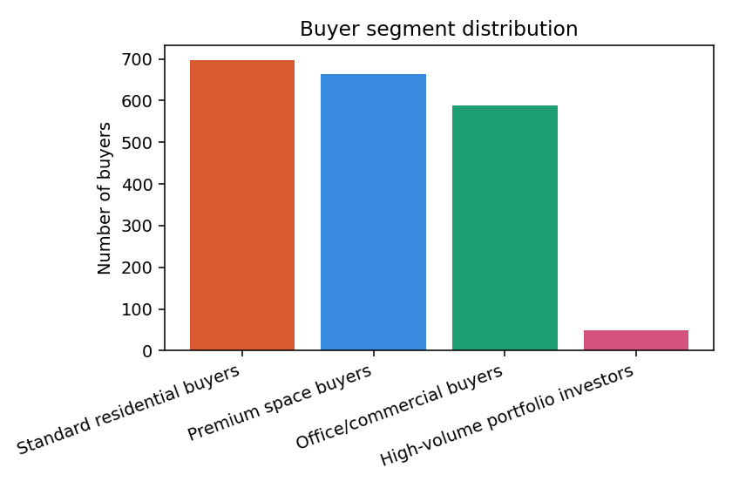
Figure 2. Number of buyers in each segment.
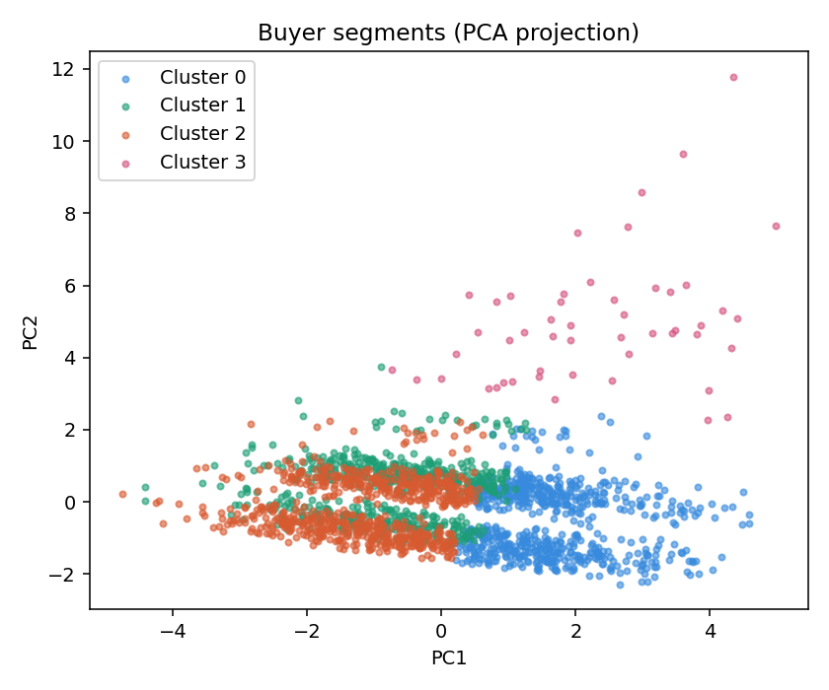
Figure 3. Buyer segments projected onto two principal components.
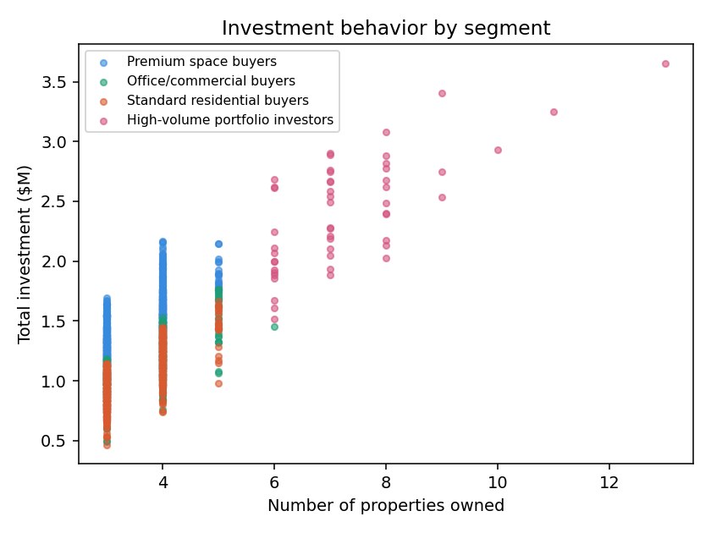
Figure 4. Total investment versus number of properties owned, by segment.
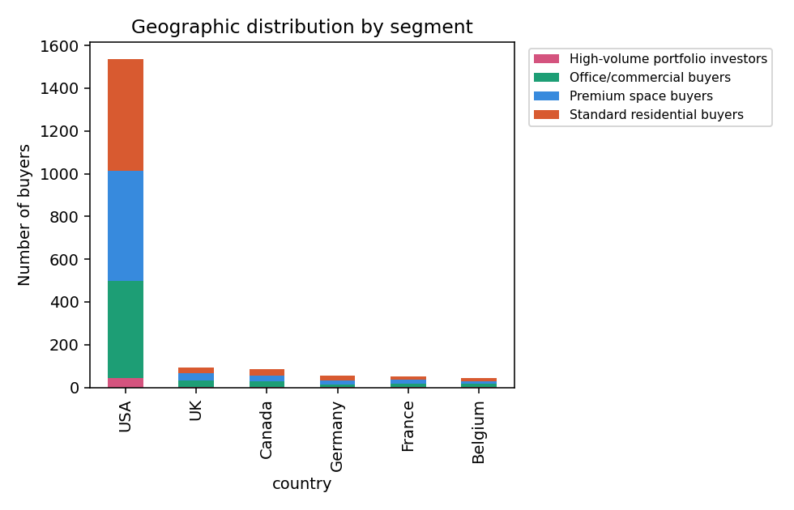
Figure 5. Geographic distribution of buyers by segment across the six largest markets.
Demographic variables (age, gender, referral channel, and country mix) were broadly similar across segments - the primary differentiators are transactional: how many properties a buyer owns, how much they have spent in total, and whether their portfolio includes office space. This suggests Parcl's buyer differences are driven more by investment behavior than by who the buyer is demographically, which has direct implications for how segments should be targeted (see Section 6).

6. Business recommendations
- High-volume portfolio investors (2.5% of buyers, largest share of capital) - assign a dedicated relationship manager and offer early access to new listings; this group's satisfaction score is already the highest, so retention matters more than acquisition.
- Office/commercial buyers - market office and mixed-use inventory specifically to this group rather than blending office listings into general residential campaigns.
- Premium space buyers - larger, higher-priced units convert well with this segment; prioritize showing larger floor plans and premium finishes in outreach.
- Standard residential buyers - the largest segment by count but lowest average spend; price-sensitive messaging and financing options (this segment's loan usage is comparable to others, so financing support is a relevant lever) are likely to perform better than luxury positioning.
- Because demographic fields did not strongly separate the segments, marketing targeting should lean on transaction history and stated acquisition purpose rather than demographic proxies alone.

7. Streamlit dashboard
A companion dashboard (app.py) implements the four modules specified in the project brief, with filters for country, region, acquisition purpose, and client type:
- Buyer segmentation overview - cluster sizes and segment definitions.
- Investor behavior dashboard - investment scale, portfolio size, and financing behavior by segment.
- Geographic buyer analysis - buyer counts and average investment by country, broken down by segment.
- Segment insights panel - descriptive statistics and channel mix for a selected segment.
The dashboard runs locally with: streamlit run app.py (requires the buyer_profiles_final.csv output from this analysis in the same folder).

8. Limitations and next steps
- Silhouette scores (0.09-0.15) indicate soft, overlapping clusters rather than sharply separated groups; treat segment boundaries as directional, not absolute, and revisit borderline buyers manually where a marketing decision has high stakes.
- K-means and hierarchical clustering agreed only moderately (ARI 0.248); before wider rollout, consider testing an additional method (e.g. Gaussian mixture models) as a further cross-check.
- The dataset does not include marketing response or conversion outcomes, so segments are behavioral profiles, not yet validated against actual campaign performance - the recommended next step is an A/B test of segment-specific messaging.
- Country and region did not meaningfully separate segments in this dataset; if geographic strategy is a priority, consider a market-specific follow-up analysis rather than relying on the global clusters.

